EXERCISE 6: CURSORS
Scenario 1: Generate Monthly Statements
Question:
Write a PL/SQL block using a cursor to generate monthly account statements by displaying all transactions that occurred during the current month.
Code
SET SERVEROUTPUT ON;

DECLARE
CURSOR c_trans IS
SELECT TransactionID,
AccountID,
TransactionDate,
Amount,
TransactionType
FROM Transactions
WHERE TRUNC(TransactionDate,'MM') =
TRUNC(SYSDATE,'MM');
BEGIN
FOR rec IN c_trans LOOP
DBMS_OUTPUT.PUT_LINE(
'Transaction ID: ' || rec.TransactionID ||
', Account ID: ' || rec.AccountID ||
', Amount: ' || rec.Amount ||
', Type: ' || rec.TransactionType
);
END LOOP;
END;
/
Execution
SET SERVEROUTPUT ON;

BEGIN
NULL;
END;
/
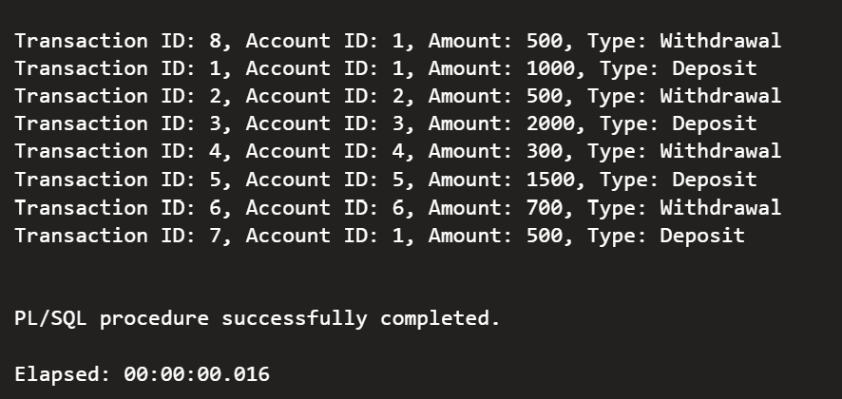
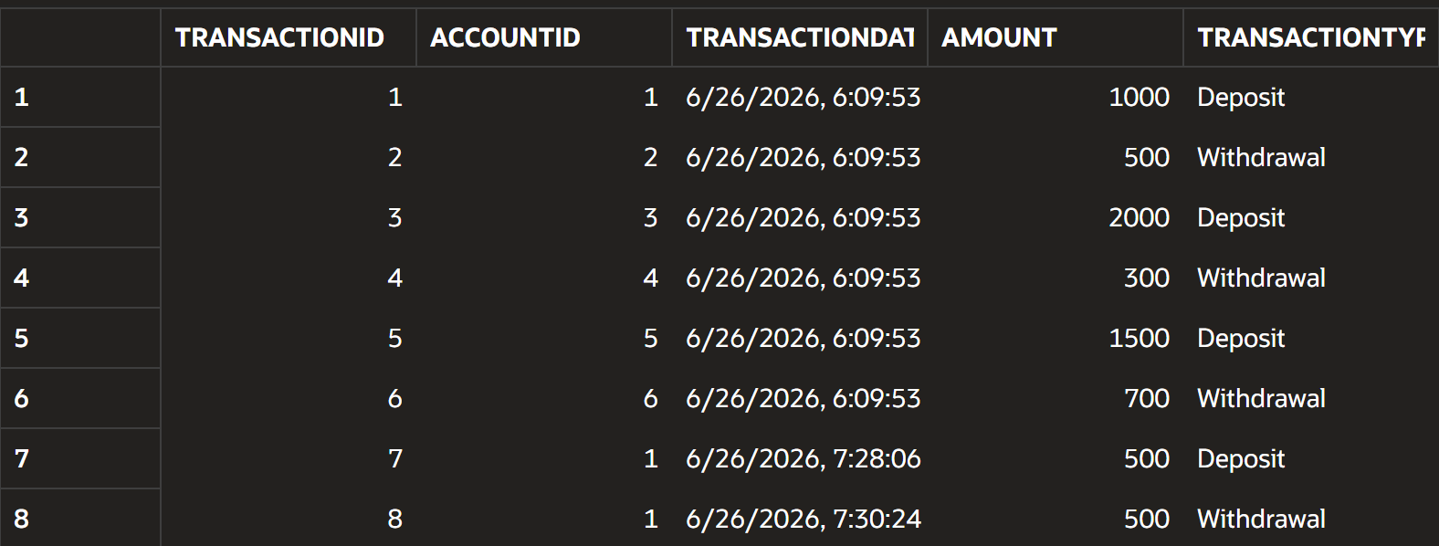

Scenario 2: Apply Annual Fee
Question:
Write a PL/SQL block using a cursor to deduct an annual maintenance fee of 100 from every account.
Code
DECLARE
CURSOR c_acc IS
SELECT AccountID
FROM Accounts;
BEGIN
FOR rec IN c_acc LOOP
UPDATE Accounts
SET Balance = Balance - 100
WHERE AccountID = rec.AccountID;
END LOOP;

COMMIT;
END;
/
Execution
SELECT AccountID,
Balance
FROM Accounts;
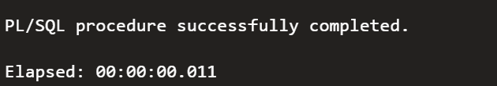
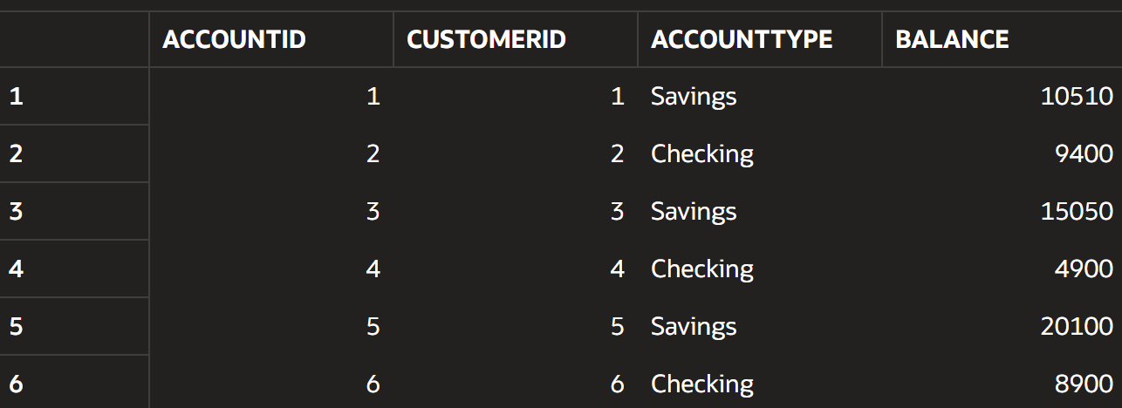

Scenario 3: Update Loan Interest Rates
Question:
Write a PL/SQL block using a cursor to increase the interest rate of every loan by 0.5%.
Code
DECLARE
CURSOR c_loan IS
SELECT LoanID
FROM Loans;
BEGIN
FOR rec IN c_loan LOOP
UPDATE Loans
SET InterestRate = InterestRate + 0.5
WHERE LoanID = rec.LoanID;
END LOOP;

COMMIT;
END;
/
Execution
SELECT LoanID,
InterestRate
FROM Loans;

